**CHAPTER 8**

**IMPLEMENTATION**

**8.1 General Handout**

The Police officers will be provided with basic printed handouts of the Predicted Criminals which would provide the following results as stated below in the Figure.

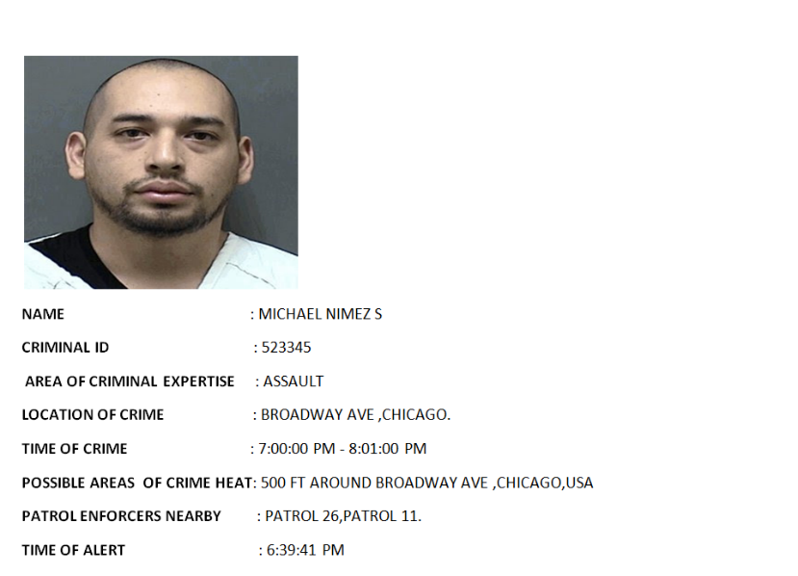

**Fig 3.1 Predicted printed Handouts of Existing Criminals.**

**8.2 Android App Layout**

The officers also have the option to have a mobile output through the provision of a mobile application. This makes it possible for the officers to carry a tracking record with themselves at all times and find it possible to nab the criminal. The output is provided based on the location of the officers or the location of available enforcers.

The officers have a special way of logging onto their profile via the Android Application. After they have typed the username and password they simply need to shake their smartphone towards their right to authenticate themselves. If they press the Login button they will be misled to a different page where it looks as though they are logged in.

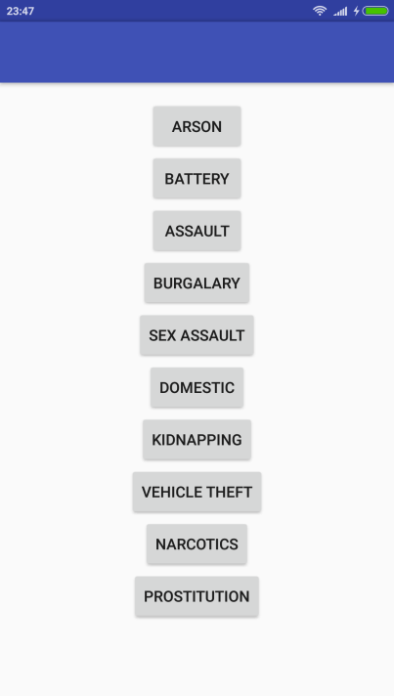 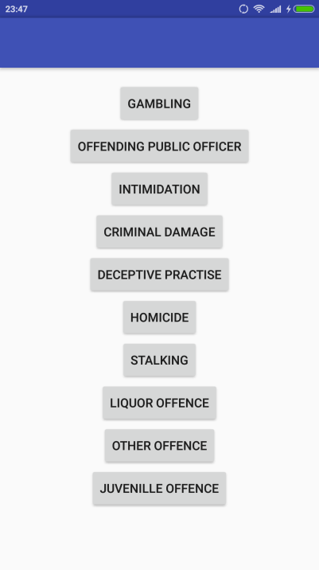

**Fig 5.1 App Layout- Primary Influential Crimes Fig 5.2 App Layout -Secondary Influential Crimes**

**8.3 Web Layout**

A webpage serve as the knowledge base about the future presence of criminal activity. Each officer has a officer id and password which serve as authentication token for the Police Department. Once logged in the officials have the ability to select the type of crime to get informed about the future happenings.

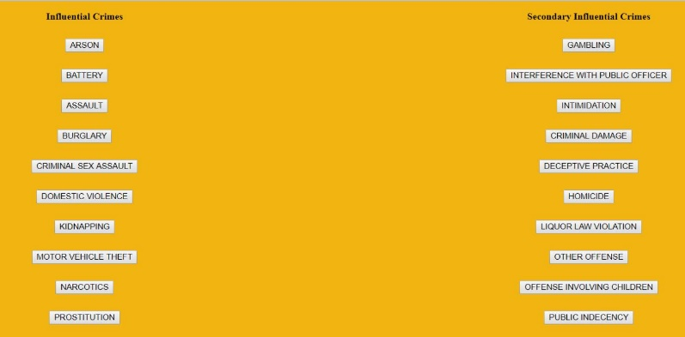

**Fig 4. Webpage layout of various Influential Crimes**